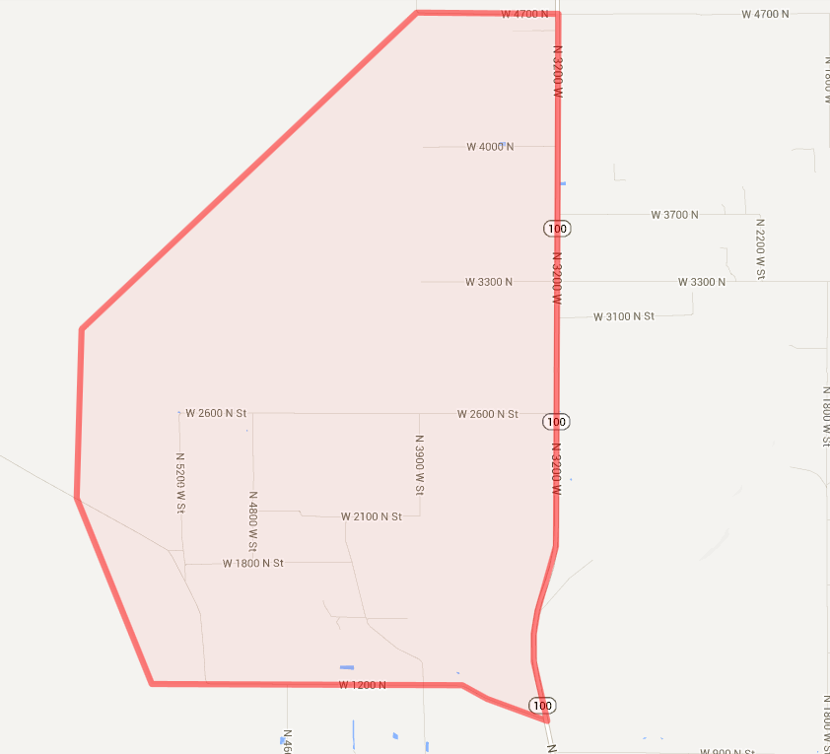


1 – Holden A

Extra Information

- Boundaries – Where the boundary line is in the middle of the street, work only one side of the street; unless the map or instructions say otherwise.
- Not-at-Homes – Please keep a record and turn them in when with the completed territory. If there's no address you can make a mark on the map to indicate its location.
- No Trespassing – Please do not visit these homes.
- Do-Not-Calls – Make a note of Do Not Calls below along with the date.
- Rural Homes – Make a mark on the map of any rural houses.
- Safety – Please use good judgment especially when working territories in bad weather or homes that are located in extremely rural areas. Some homes hidden in remote areas may require caution.
- For rural areas, if you suspect there are homes in an area not included on the map, please make a note so we can adjust the maps.

Address | Date

